July 2016

The summer is our busy field season at IBP, but we thought we'd take a pause to summarize some of our recent publications
New information on a rare bird: Great Gray Owls found nesting in atypical, low-elevation habitat

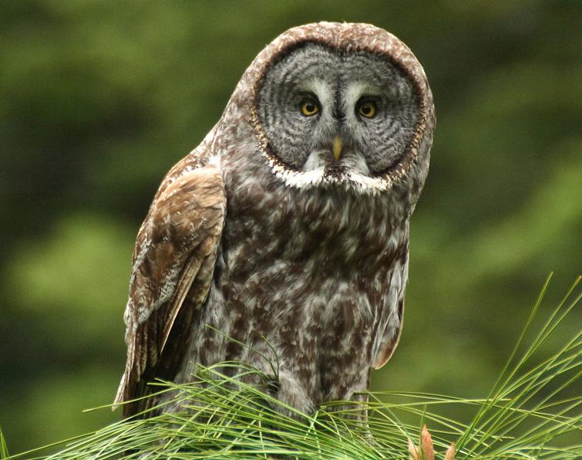
Recent research by IBP and others has revealed new information about nesting habitat for California-endangered Great Gray Owl.
Great Gray Owls in the Sierra Nevada were once believed to nest strictly in mid-elevation conifer forests near montane meadows, but recent observations are challenging this notion. In a paper published this summer in The Journal of Raptor Research, IBP scientists Julia Polasik, Joanna Wu, and Rodney Siegel, and Sierra Pacific wildlife biologist Kevin Roberts describe the reproductive success and habitat associated with Great Gray Owl nests on commercial timberlands in the lower-montane zone of the central Sierra Nevada. The results suggest that mixed oak-conifer woodlands in the lower-montane zone, even in the absence of wet meadows, may provide important habitat for this California-listed endangered species.

Overall, reproductive success was high, with several breeding attempts producing three fledglings, and an average of 1.9 young fledged per breeding attempt. Nests were in large-diameter trees, even though smaller-diameter trees dominated the surrounding landscape, which was composed primarily of dense mixed conifer and hardwood forest interspersed with annual grasslands. Using modeling, the authors also identified areas in 10 counties of the central and northern Sierra Nevada that have potential for nesting habitat and should be surveyed. Identifying such locations could focus efforts to determine if this hard-to-detect species is already nesting there, perhaps in numbers that may be a significant component of the very small statewide population.

Polasik, J.S., J.X. Wu, K. Roberts, and R.B. Siegel. 2016. Great Gray Owls nesting in atypical, low-elevation habitat in the Sierra Nevada, California. The Journal of Raptor Research 50:194-206. (For a copy of this publication, please contact rsiegel@birdpop.org.)

